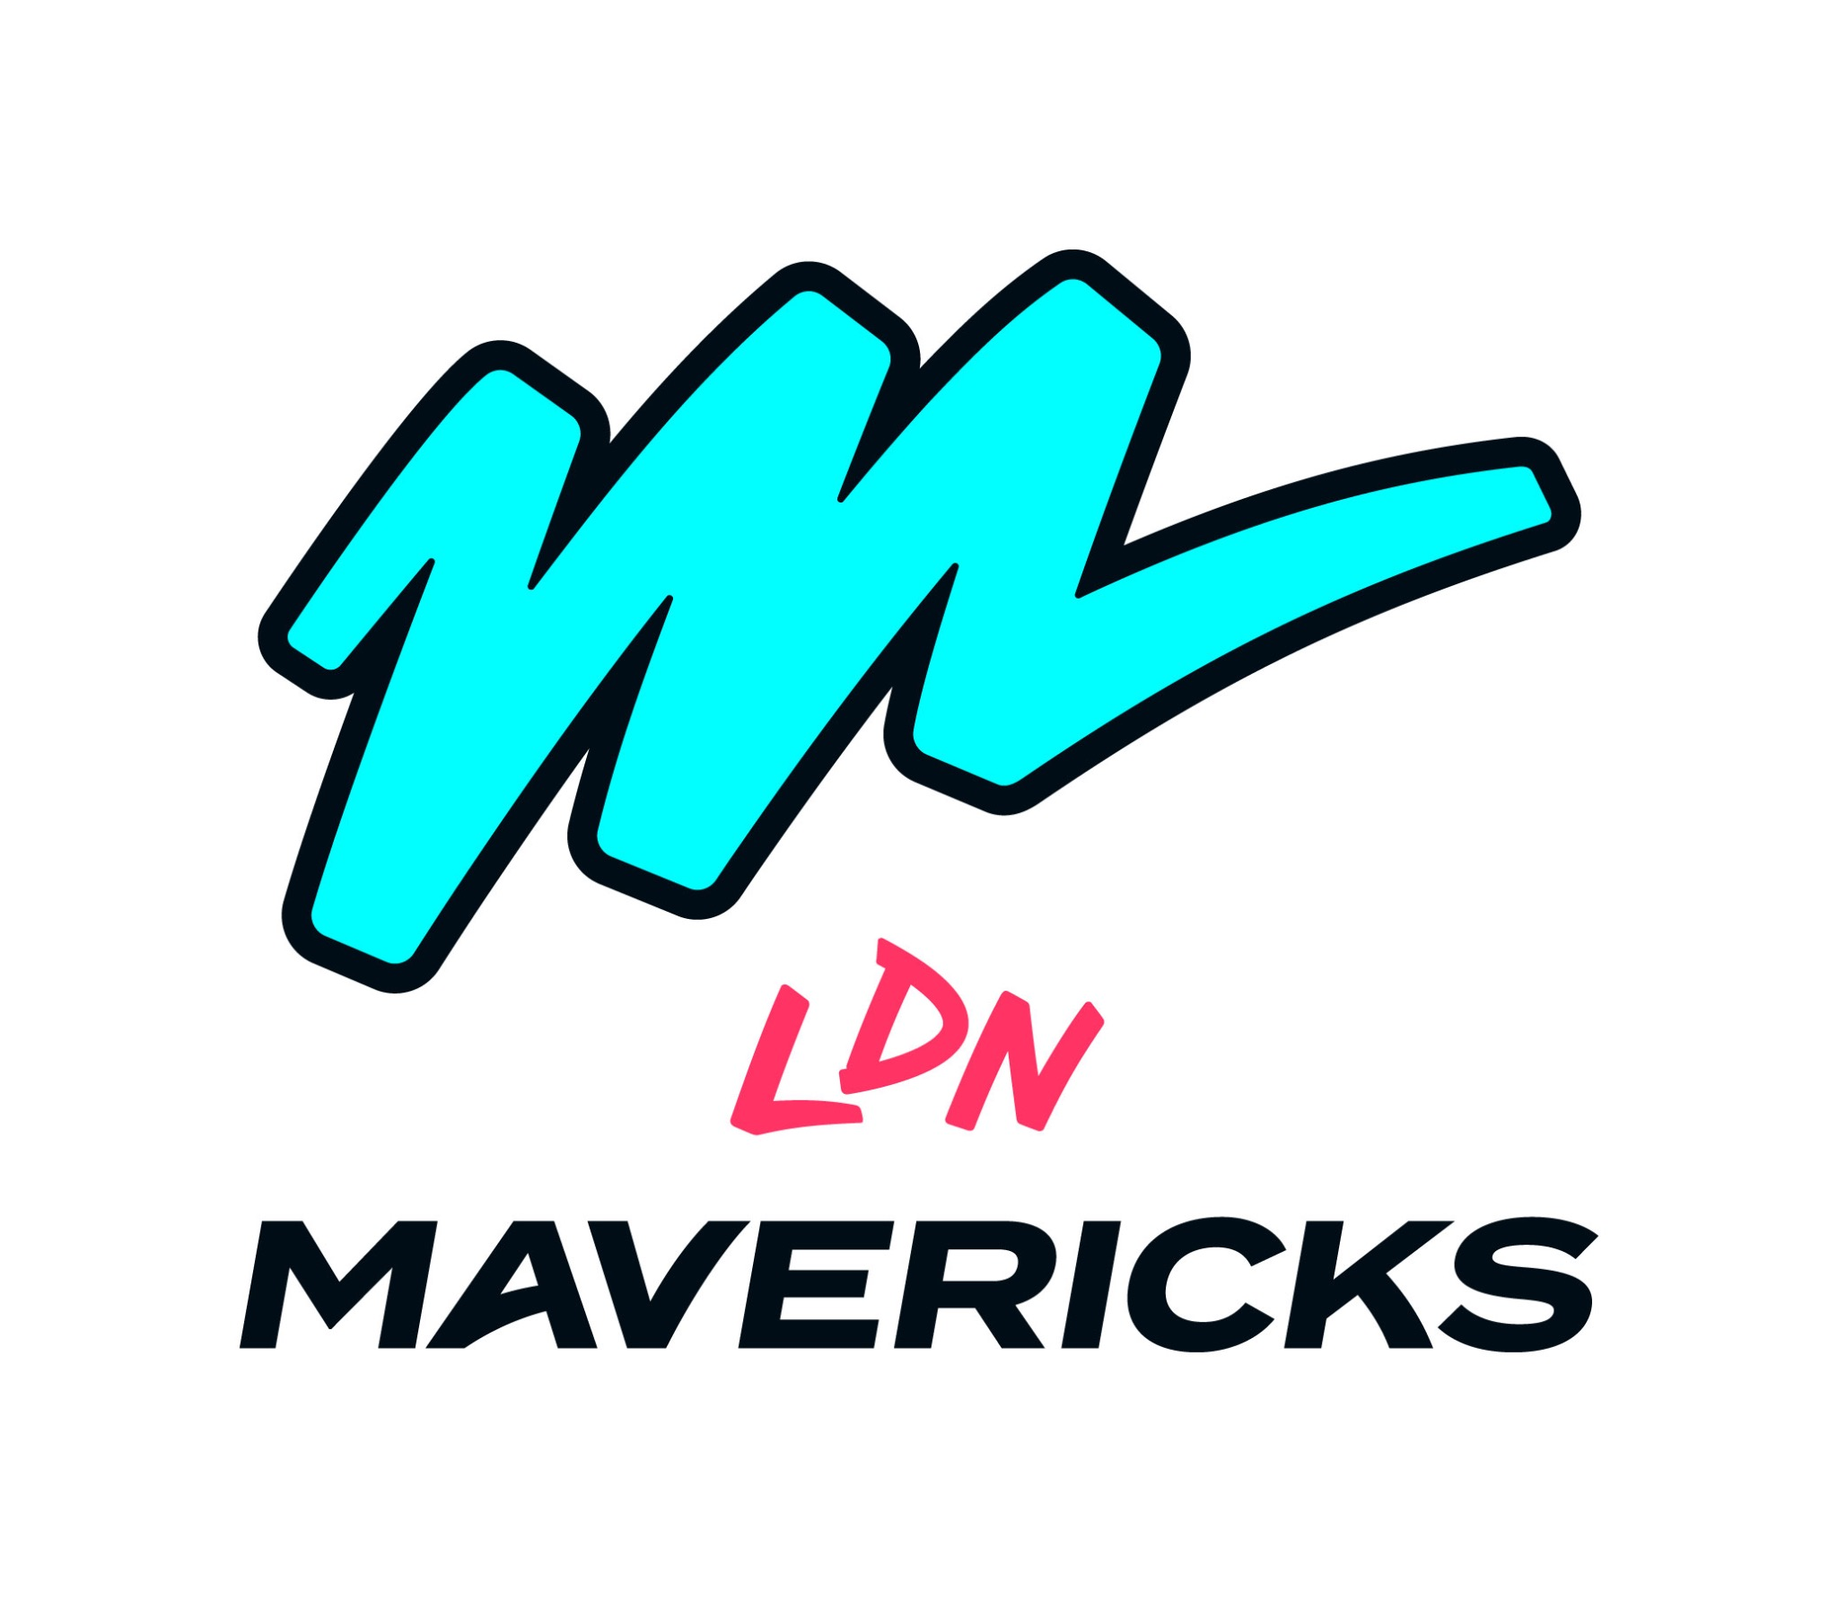
Data Protection Policy (2026/27)
1. Introduction
London Mavericks Netball Club LTD ("the Club") is committed to protecting and respecting the privacy of all individuals whose personal data we process.
This policy reflects our obligations under the UK General Data Protection Regulation (UK GDPR), the Data Protection Act 2018, and evolving best practice for 2026/27.
2. Purpose
This policy ensures that personal data is handled lawfully, fairly, and transparently, and that appropriate safeguards are in place to protect individuals' rights.
3. Scope
This policy applies to all personal data processed by the Club, including members, staff, volunteers, partners, suppliers, and digital platform users.
It applies to all employees, contractors, and volunteers.
4. Data Protection Principles
The Club adheres to the UK GDPR principles:
- Lawfulness, fairness and transparency
- Purpose limitation
- Data minimisation
- Accuracy
- Storage limitation
- Integrity and confidentiality
- Accountability
5. Lawful Basis for Processing
The Club processes personal data under lawful bases including consent, contract, legal obligation, and legitimate interests.
We ensure individuals understand how their data is used, particularly in marketing, safeguarding, and performance environments.
6. Individual Rights
Individuals have rights including access, rectification, erasure, restriction, portability, objection, and rights relating to automated decision-making.
Requests will be responded to within one month.
7. Data Security
We implement appropriate technical and organisational measures including:
- Secure systems and access controls
- Password protection and multi-factor authentication where appropriate
- Regular system updates and staff training
Data is only accessible to those who require it.
8. Data Breaches
All breaches must be reported immediately. Where required, breaches will be reported to the ICO within 72 hours.
A breach log will be maintained and reviewed to prevent recurrence.
9. Data Retention
Data is retained only as long as necessary. Retention schedules are maintained and reviewed annually.
Data will be securely deleted when no longer required.
10. Data Sharing
Data is only shared where lawful and necessary. Third-party processors are subject to contracts ensuring GDPR compliance.
International transfers will include appropriate safeguards where applicable.
11. Responsibilities
The Data Protection Officer oversees compliance.
All staff and volunteers must complete data protection training and follow this policy.
12. Digital and Marketing Data (Updated for 2026/27)
We use digital platforms, CRM systems, and social media to engage with fans and stakeholders.
We ensure:
- Consent is obtained where required for marketing
- Clear opt-out mechanisms are provided
- Data collected through digital channels is secure and compliant
13. Review
This policy will be reviewed annually.
Effective Date: 1st July 2026
Last Reviewed: 19th March 2026
Contact
For queries, contact:
Kieran Crombie
KieranCrombie@MaverickSportsGroup.co.uk

